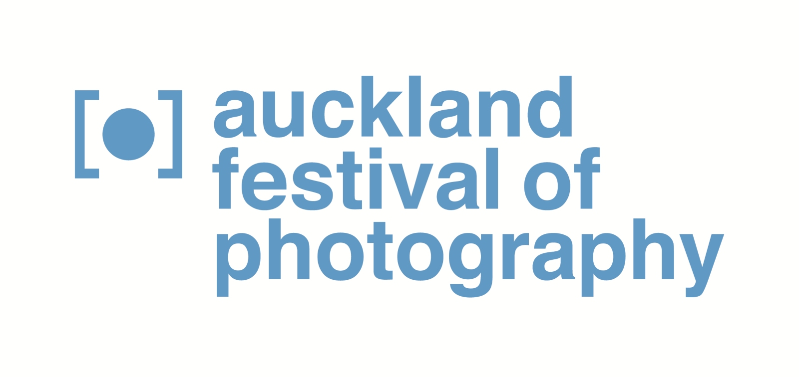Media release, April 2015 1/1

Truth & Fiction and 2015’s Auckland Festival of Photography
Truth & Fiction is a central theme in 2015’s Auckland Festival of Photography - which features 100 events and exhibitions from May 28 to June 20.

“We are proud the 2015 line-up cements the Auckland Festival of Photography’s position as a leading event in the Asia Pacific region that attracts leading New Zealand-based and international photographers” says public participation director Julia Durkin. “AFP is a highlight in the winter events calendar. It has become the region’s largest free visual arts festival and we invite audiences to engage with and enjoy what’s on offer in our twelfth annual festival.”

2015’s AFP includes ten Truth & Fiction exhibitions that span documentary and digitally constructed photography, a Talking Culture symposium on Photobook Stories [30 May] and rich pickings on everything from documentary to celebrity photography. Other festival treats are the Annual Commission by Sacred Hill, featuring new work by P J Paterson, the popular Whitecliffe Festival Tuesday [2 June] and a string of signature and community-based exhibitions across Auckland.

“PJ Paterson’s work is an exhilarating mix of contemporary aesthetic and political engagement,” says Commission curator, Elaine Smith. Paterson’s work will be on show during 2015’s AFP before being shown at the Pingyao International Photography Festival. As part of the 5th year celebration of the Annual Commission, all previous AFP commissioned work by Tanu Gago, Jennifer Mason, James K Lowe and Roberta Thornley will be exhibited at the Pah Homestead during the Festival.

2015 sees several AFP exhibitions at the Auckland Art Gallery - including new work by Lisa Reihana with in Pursuit of Venus [infected] and Laurence Aberhart within ANZAC . As well as Silo 6 exhibitions featuring work by leading international artists, AFP also presents international photojournalism digital projections, direct from one of Asia’s most respected photographic events, the Angkor Photo Festival, and for the first time in New Zealand, Magnum Workshops [28 May to 1 June], hosted by Whitecliffe College. Magnum photographers’ work will also be on show in the New Zealand premiere of Offside Brazil, an exhibition of works in response to Brazil hosting the 2014 Brazil FIFA World Cup.

“The Auckland Festival of Photography is committed to presenting Auckland audiences with cutting-edge work produced by the best practitioners in this the most important art form of our times,” says Julia Durkin. “Photography brings us up close and personal to moments that we value, as well as engaging us with issues we need to consider or confront.”

Details of AFP events and exhibitions, including 53 Fringe exhibitions across the region, are available in our programme: http://www.photographyfestival.org.nz/programme/index.cfm

For more information and interview opportunities, please contact:
Victor van Wetering, media manager, Auckland Festival of Photography, (09) 849 6565.

Like us on Facebook, “Auckland Festival of Photography”.
Follow us on Twitter: @AklPhotoFest

Auckland Festival of Photography 2015
Funding partners: Auckland Council, ASB Community Trust, Creative New Zealand
Festival Sponsors: Sacred Hill, Whitecliffe College of Arts&Design, momento, HP
International Partners: Asia Pacific Photoforum, PIP, Head On, Higashikawa Intl. Photo Festival, Kaunas Photo Festival
Community & Cultural Grants: Creative Communities, COGS, The Lion Foundation, The Trusts, Chartwell Trust.

