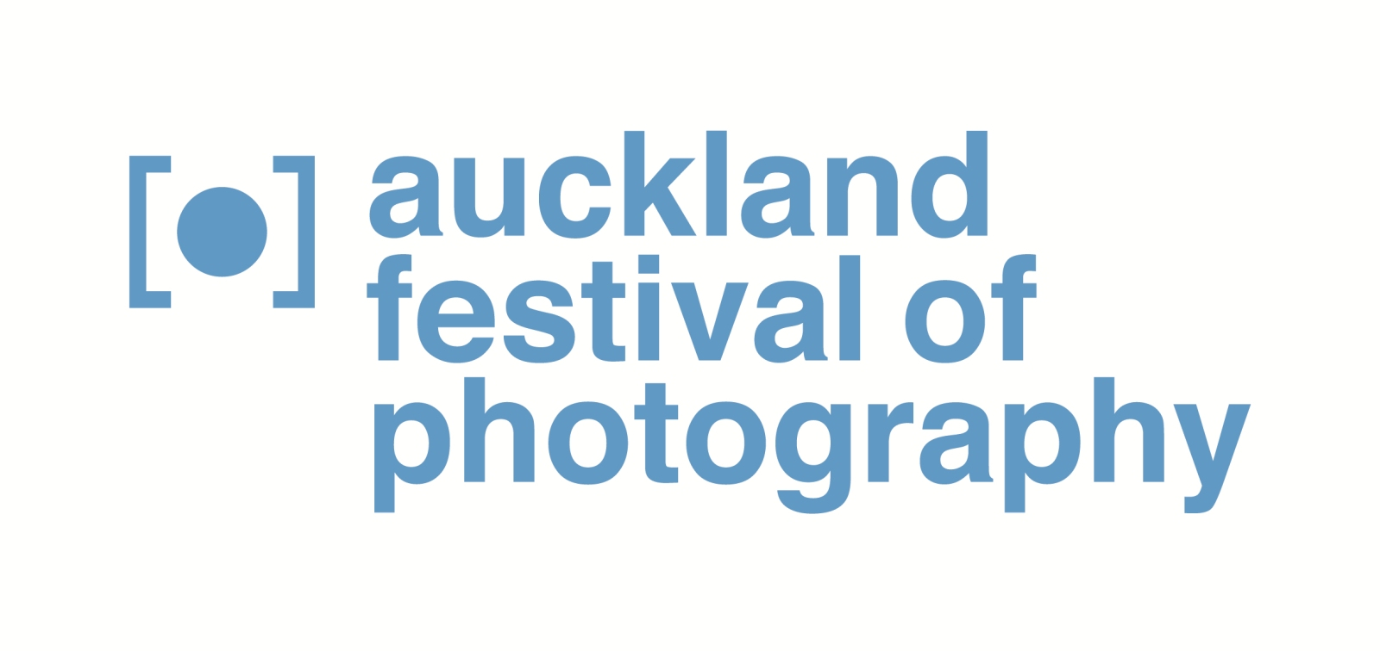

Media release April 2014

2014’s Auckland Festival of Photography record numbers with 115 events and exhibitions

Memory is a central focus for 2014’s Auckland Festival of Photography - which features a record 115 events and exhibitions from May 29 to June 20. Since the Auckland Festival of Photography Trust started the annual festival in 2004, it has attracted an impressive line-up of New Zealand-based and international photographers and become a highlight in the winter events calendar. Its scale and reach across the Auckland region has grown to the extent that it is now the region’s largest free visual arts festival and Australasia’s leading photographic event.

The memory theme is explored in Talking Culture events, including the festival’s annual symposium and Sunday series and festival exhibitions . Within its three week time frame, 2014’s festival features the work of Tanu Gago in its Annual Commission by Sacred Hill, signature exhibitions, and community-based fringe exhibitions across Auckland. Popular festival events returning in 2014 include Festival Tuesday on 3 June, and Nikon Auckland Photo Day on 7 June. Since 2004, the festival’s annual “24 hours in Auckland” competition has seen Aucklanders capture their present and region, contributing to an archive that will ultimately inform perceptions of our past.

This year’s international content has been boosted by a major coup, securing an exhibition of the Nikon Photo Contest 2012-2013 Award Winners. The 2012-2013 competition attracted nearly 100,000 entries, exemplifying photography’s capacity for participation and communication. As well as exhibitions of leading international photographers’ work, the festival has invited top practitioners to contribute to its Talking Culture Symposium.

“The Auckland Festival of Photography celebrates the most important art form of our times with the communities of Auckland,” says Festival spokesperson, Julia Durkin. “Photography captures the magic of light. It brings us all a little closer to those special moments that we want to keep, and our audience by seeing images through eyes of others, helps us build cultural experiences within and beyond New Zealand. The festival is a stage for Aucklanders to present their work alongside leading national and international photographers.”

For more information and interview opportunities, please contact:
Victor van Wetering, media manager, Auckland Festival of Photography, (09) 849 6565.

Like us on Facebook, “Auckland Festival of Photography”.
Follow us on Twitter: @AklPhotoFest

Auckland Festival of Photography 2014
Major funder: ASB Community Trust
Local Government Funder: Auckland Council
Festival Sponsors: Nikon & Sacred Hill & HP

International Partners: Asia Pacific Photoforum, Head On Festival, Pingyao International Photo Festival, Nikon Photo Contest
Community & Cultural Grants: Creative Communities, COGS, The Lion Foundation, Asia NZ, The Trusts.

Full 2014 programme at www.photographyfestival.org.nz

