Media release, June 2018 1/4

Gritty sporting sub culture portrait
wins 2018 Nikon Auckland Photo Day
The winners of 2018’s Nikon Auckland Photo Day have been decided:

First prize: Celebration by Nick Depree
Second prize: Tea in the Sun by Gail Orgias
Third prize: Early Birds by Susan Park
Moving image winner: Fellowship at Scandrett by Sora Joseph Waningsinggel

The judges sifted through approximately 1000 entries for this year’s 24-hour day in the life of Auckland competition, held on Saturday 9 June. The entries add to a unique archive of more than 10,000 images taken of Auckland since the competition began in 2004. This year’s competition was judged by multimedia artist Janet Lilo, Daylight Books photobook publisher Michael Itkoff and Nikon New Zealand Professional Support Manager Blair Quax. Images can be viewed at https://www.dropbox.com/sh/tg3h1azygrooker/AACG4exaVcz8HCayXXvJJOrFa?dl=0
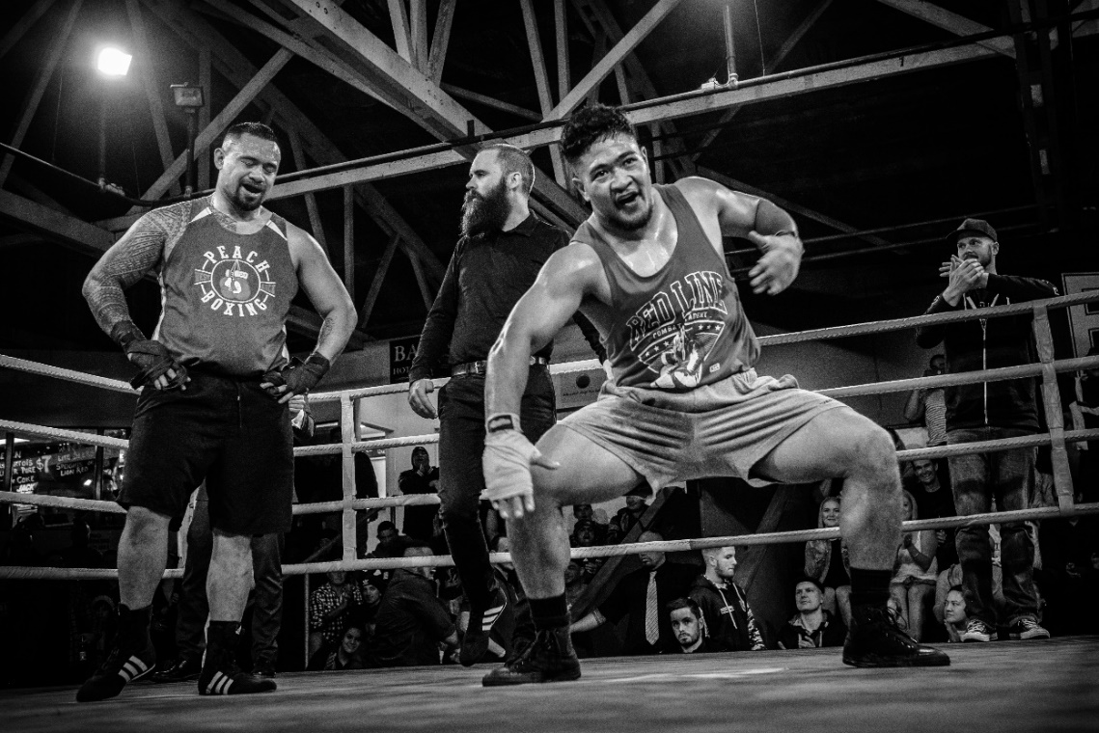
Celebration by Nick Depree, Grey Lynn - First prize - Nikon D5600 Kit – a DX-format camera packed into
a compact and lightweight frame, paired with a versatile Nikkor 18-55mm lens.

Judges’ comment: “This year’s winning photograph is simply a knock out. A strong black and white image placing the viewer in the ring close to the action.”

Nick Depree, a university lecturer and researcher, was out with friends avoiding the All Blacks vs France match on the night of Nikon Auckland Photo Day. “This image is of an Auckland Boxing Association Event. I was the only one shooting it. I don’t usually shoot sport at all but I enjoy getting up close and used a wide-angle lens.”
Media release, June 2018 2/4

The announcement of Nikon Auckland Photo Day winners marks the close of 2018’s festival, which featured more than 100 exhibitions and events, including a series of Control-themed exhibitions, almost 50 Satellite exhibitions across the region, and an extensive Talking Culture public programme.

The judges’ prize winners and shortlist of 30 entries for this year’s competition can be seen at http://www.photographyfestival.org.nz/photo-day/peoples-choice/index.cfm from Friday 22 June - when online voting for the People’s Choice category of 2018 Nikon Auckland Photo Day opens. The winner receives the Nikon COOLPIX P900 - a compact superzoom with built-in WiFi ®, NFC functionality and a 16.1 megapixel sensor.

"As a proud partner of the annual Auckland Festival of Photography, Nikon New Zealand appreciate the chance to explore the moments of creative expression and technical precision that are captured over the frenzied 24-hour period of Auckland Photo Day,” says Blair Quax, Professional Support Manager, Nikon New Zealand. “Inspired by the people and places that make Auckland so unique, we have once again been on a journey through the singular vision of the photographer."
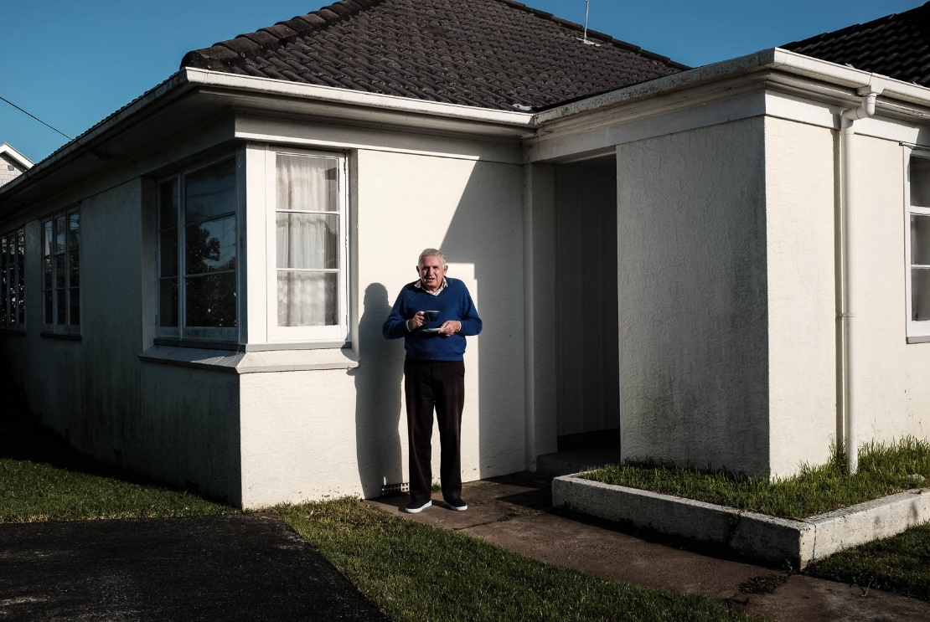
Tea in the Sun by Gail Orgias, Freeman’s Bay - Second prize, a Nikon D3400 Kit -
a sharp shooting compact DX-format DSLR, paired with a Nikkor 18-55mm lens.

Judges’ comment: “A quiet Saturday morning and cup of tea in sunny suburbia. This image reminded us of iconic New Zealand with a nod to Robin Morrison’s depictions of the everyday. It speaks to a sense of place.”

Photographer’s quote. “I just took one image that day, in Westmere. I don’t know the gentleman personally but he was happy to have his photograph taken. It was just such a typical scene. I like street photography and generally walk around with a camera as much as I can, usually in the city. It just so happened that day were heading out that way. I’m a keen photographer and generally go to as many of the Auckland Festival of Photography events as possible.”
Media release, June 2018 3/4

AFP public participation director Julia Durkin was heartened by the community support for 2018’s competition. “Nikon Auckland Photo Day seeks an answer to significant social and cultural questions. What did you do on Saturday 9th June? What memories were created in your life? The nearly 400 photographers that participated in the 24-hour challenge, makes Nikon Auckland Photo Day, once again the biggest community photo shoot in New Zealand on any given day,” Ms Durkin says. “The event provides a unique time-capsule of Auckland’s visual diversity. We are proud that in this, the Auckland Festival of Photography’s 15th year, so many great images have been created by the people of Auckland. These images are now part of the largest cultural archive of democratic participation of any festival in the city’s history. We are delighted again to partner with Nikon to share Nikon Auckland Photo Day with the community.”

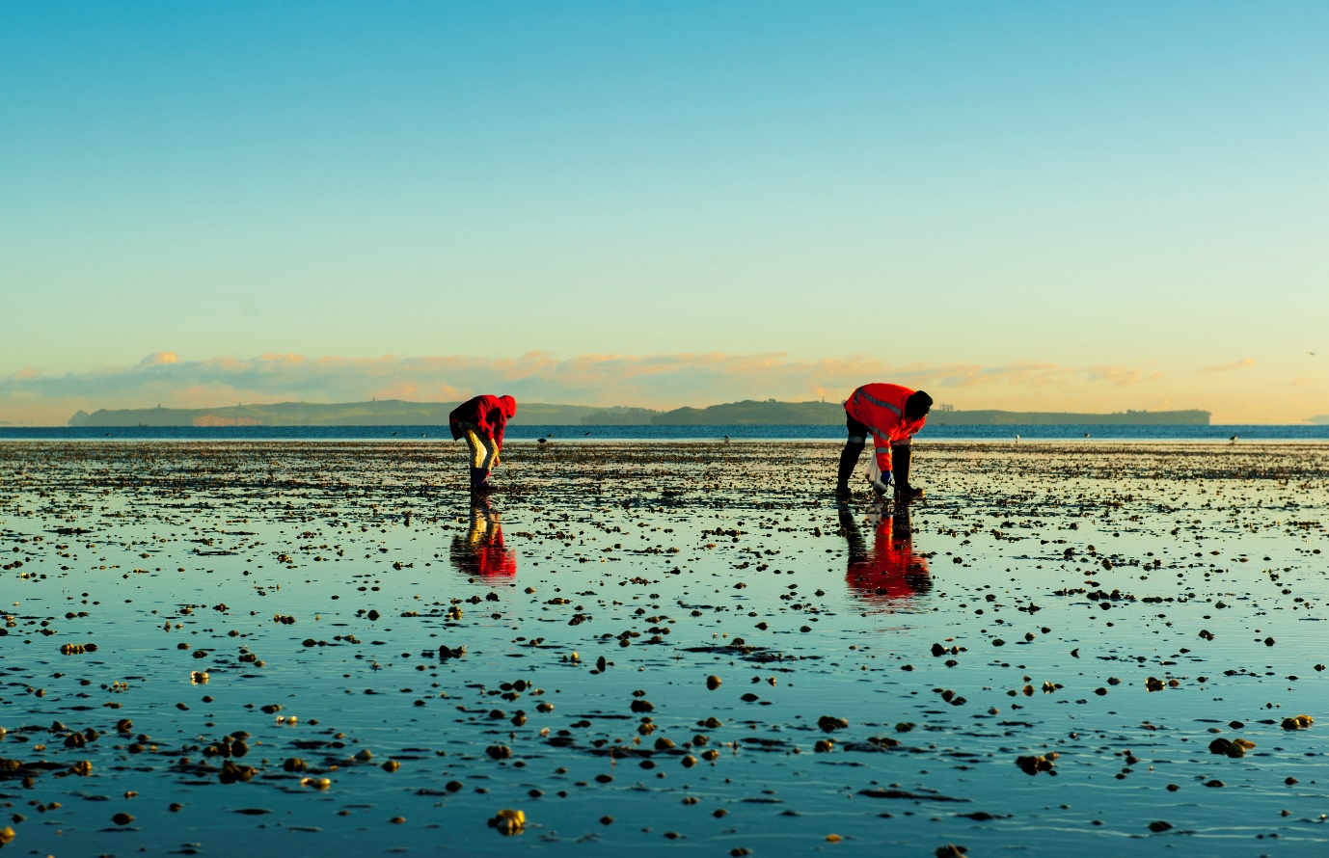

Early Birds by Susan Park, Goodwood Heights - Third prize, a Nikon 1 J5,
with extreme portability, style and imaging power, with a compact Nikkor 10-30mm lens.

Judges’ comment: “We loved the symmetry and poppy colours against the horizon and reflected in a landscape of wet sand, birds and pipi. We also loved the quiet nature of this image and the stillness of the morning’s gathering.”

Photographer’s quote: “The photograph was taken early in the morning. Me and my husband Hender are retired and enjoy taking photographs every day in different parts of Auckland. On that day we went to Cockle Bay. My husband also put three images into the competition but my photograph won. We like taking photographs on Nikon Auckland Photo Day and that place and time of day were just right.”
Media release, June 2018 4/4

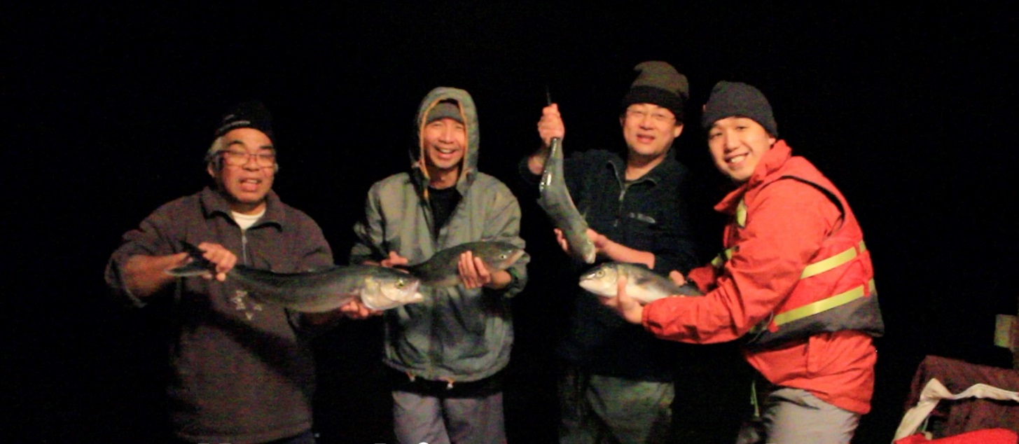

Fellowship at Scandrett by Sora Joseph Waningsinggel, Onehunga - Moving Image prize, a Nikon KeyMission 360. Shockproof, waterproof 4K enabled action camera allowing you to take full 360 degree footage in beautiful 4K.

Judges’ comment: “This fun montage took us on a family fishing excursion over a complete day, culminating in an evening meal. The day out captures the spirt of the 24-hour idea of the competition. It’s a wonderful sojurn with a family in our region on a lovely winter’s day.”

Photographer’s quote: “This is the fourth time we’ve gone on a family trip to Scandrett Regional Park with our friends. The place is really nice and we can be right by the sea. When I knew the Nikon Auckland Photo Day competition coincided with our trip, I thought I would capture it. Because the activity was fun I wanted to make sure the video looked like fun too.”
This is the second year in a row the Onehunga graphic designer has won a Nikon Auckland Photo Day prize, taking out the top prize in 2017. “Winning a prize again is great. Winning this category was a really nice surprise since it was the first time I have entered a moving image entry.”

For more information and interview opportunities, please contact:
Victor van Wetering, media manager, Auckland Festival of Photography, (09) 849 6565.
Bev Goodwin, Auckland Festival of Photography, (09) 307 7055 or info.photo.festival@xtra.co.nz

