Auckland Festival of Photography awards Annual Fine Arts Commission 2012

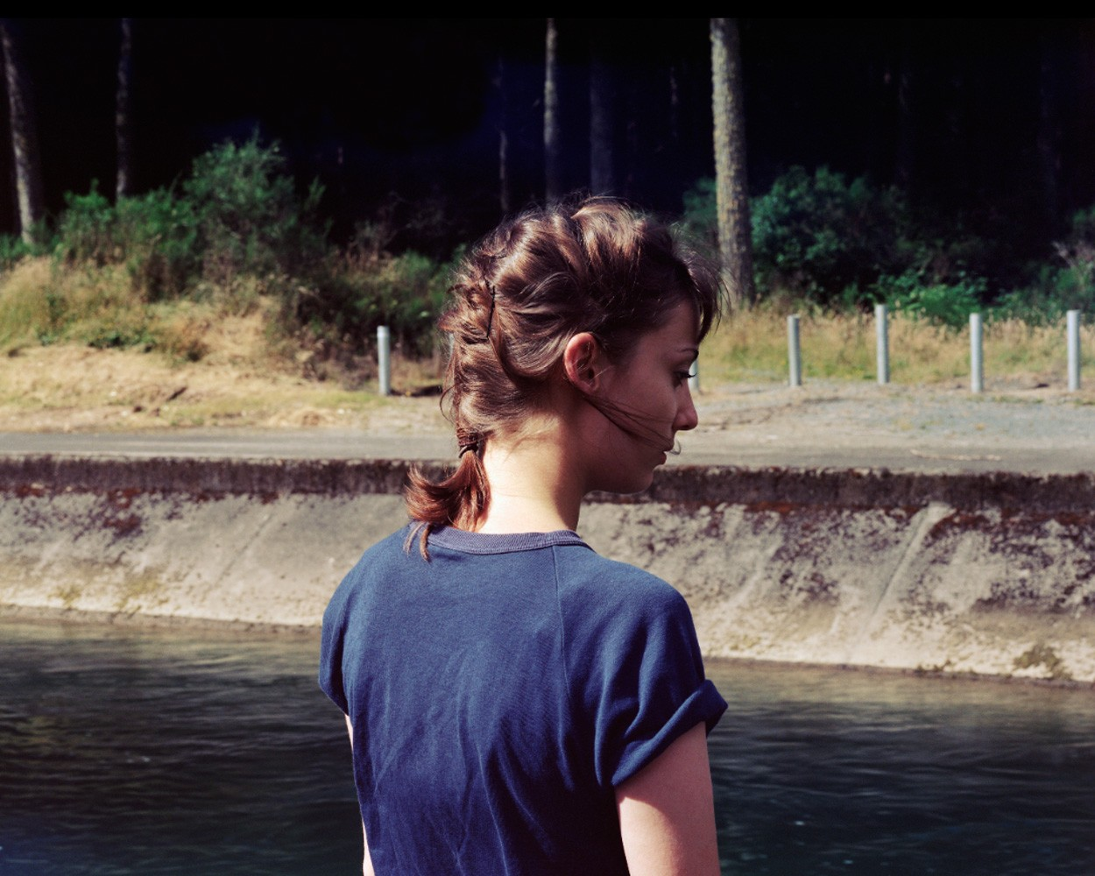Auckland, New Zealand (April 2012) –

Auckland Festival of Photography is delighted to announce that James K Lowe is the recipient of the Annual Fine Arts Commission 2012.

2012 is the second year the Auckland Festival of Photography has presented a Commission of this nature. It is the sole annual public commission of photographic art by a fine arts photographer in New Zealand.

The Commission provides an opportunity to support and promote a photographic artist of great talent as well as create an important cultural and artistic asset for present and future Auckland audiences to enjoy.

James K Lowe will create new works for this exhibition, continuing with the themes explored in his "In an Honest World" series exhibited both here and at Paris Photoquai. The commission will form the next stage of this young artist’s work.

James said, “The Commission is a huge support and recognition for my own work, and belief in what I do. My work often requires funding in the thousands for every photograph I take: from film costs, models, lighting and printing. My proposal to the Festival surrounded the idea of encapsulating old and new work from the past 4 years. To create an exhibition that follows a narrative I have been working on since studying at Elam School of Fine Arts. I am very pleased with what is to come from the Commission and ecstatic about being able to create new work to complete the narrative in its entirety.”

"The importance of the Annual Fine Arts Commission is going to build each year and this year's recipient, James K Lowe, is a fitting example of the Festival's commitment to supporting Auckland artists," said Elaine Smith, spokesperson for the Auckland Festival of Photography.

The full programme for the 2012 Auckland Festival of Photography will be announced on 12 April.

For more information and interview opportunities, please contact:

Alistair Kwun

Media Manager
Auckland Festival of Photography
media.photofestival@xtra.co.nz
+64 21 774 789

Auckland Festival of Photography 2012 is funded by ASB Community Trusts, Auckland Council and Creative New Zealand.

Sponsored by Nikon and Lowepro and MAXX.

Cultural and Community funders: Lion Foundation, SKYCITY Community Trust Auckland, Creative Communities regional, COGS Waitakere, Papakura/Franklin, Auckland City and Manukau and The Trusts. Media Partner: D Photo. Special Thanks to Gravity Coffee.

Photo credit: The Channel, James K Lowe

ABOUT JAMES K LOWE

James K Lowe is based in Auckland. He is represented by McNamara Gallery.
http://www.jamesklowe.com

