Media release, June 2017 1/4

Waka at Takapuna Beach image wins
2017 Nikon Auckland Photo Day

The winners of 2017’s Nikon Auckland Photo Day have been decided:

First prize: Waka Races at Takapuna Beach by Sora Joseph Waningsinggel
Second prize: Winter Swim by Brooke Waterson
Third prize: Victor by Dustin McNeilage
Moving image winner: Morning with the Chans by Michelle Vergel de Dios

The judges sifted through hundreds of entries for this year’s 24-hour day in the life of Auckland competition, held on Saturday 10 June. The entries add to a unique archive of more than 12,000 images taken of Auckland since the competition began in 2004. This year’s competition was judged by Chris Traill, photographer, FNZIPP, Andrew Graham, for Nikon NZ and Sylvie Whinray, photographer, winner 1st prize Nikon Auckland Photo Day 2016.
Waka Races at Takapuna Beach by Sora Joseph Waningsinggel, Onehunga - First prize, a Nikon D5600, a DX-format camera packed into a compact and lightweight frame, paired with a versatile Nikkor 18-55mm lens.
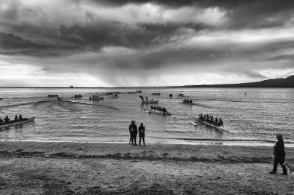

Judges’ comment: “This image took us back in time, referencing the history of Aotearoa. It echoes our past and reflects contemporary society. We were impressed with the scale and detail of this dramatic image.”

“I am a graphic designer but photography is my hobby,” Sora Joseph Waningsinggel says. “I have been taking photographs for ten years in New Zealand because it is so beautiful here. I am from Indonesia originally. I like taking scenery photographs and Takapuna is a familiar place for us because sometimes we walk there in the morning to watch the sunrise. There was a special event, a waka race, on June 10, so it was a good opportunity to get something different. I had been saving money for a Nikon camera so winning this prize is great.”
Media release, June 2017 2/4

The announcement of Nikon Auckland Photo Day winners marks the close of 2017’s festival, which featured more than 100 exhibitions and events, including a series of Identity-themed exhibitions, more than 50 Satellite exhibitions across the region, and an extensive public programme.

“Nikon are very proud to be a key sponsor of such a great Festival that celebrates community and photography and high calibre of work from Aucklanders,” says Andrew Graham, Nikon NZ Product Manager, Lacklands. “Nikon are very pleased that, once again, Aucklanders have embraced the opportunity to create new images of the scenes, people and places that reflect their region and its richly diverse surroundings.”
Winter Swim by Brooke Waterson, Mt Wellington - Second prize, a Nikon D3400
a sharp shooting compact DX-format DSLR, paired with a Nikkor 18-55mm lens.

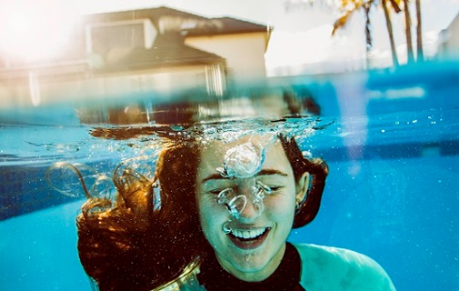

Judges’ comment: “We all liked this image from the start. It has great energy and is a playful depiction of suburbia.”

“I am a student at the University of Auckland,” Brooke Waterson says. “I have been doing photography since high school and have been doing freelance work, and events photography. I saw the competition and I had this kind of crazy idea of doing an underwater picture. I had this idea of submerging a fish tank in a swimming pool so I could photograph through it. So it’s a picture of my friend, taken through a fish tank - with me holding the fish tank between my feet, then reaching my hand down to take the shot. The water was freezing cold. My friend suffered through it for the art.”
The judges shortlist of 30 entries for this year’s competition will be on display in the Auckland Museum Atrium from 23-30 June, with online voting for the People’s Choice category opening at the same time at http://www.photographyfestival.org.nz/photo-day/peoples-choice/index.cfm

“Auckland Museum is delighted to be able to share these fantastic photographs free to Aucklanders. The images portray the diversity of life in our city and it’s wonderful to collaborate with the Festival to be able to bring these images to the public in a large-scale format,” says Auckland Museum director Dr David Gaimster.
Media release, June 2017 3/4

Victor by Dustin McNeilage, Birkenhead - Third prize, a Nikon 1 J5, with extreme portability, style and imaging power, with a compact Nikkor 10-33mm lens.

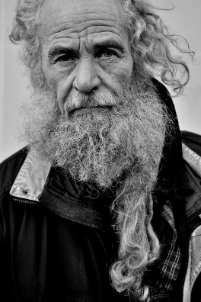

Judges’ comment: “A powerful, engaging portrait, perfectly executed.”

“I’m a Dad and a foreman for a building company,” Dustin McNeilage says. ”Photography is a hobby which I’m interested in and with any spare time I head into the city to take pictures of what presents itself. I spend several hours wandering the city at a time. I like to shoot in black and white and generally like to talk to people as I take photographs because everyone has a story. Victor was a man I met in Lorne Street on Nikon Auckland Photo Day. I think he was a homeless man and I asked if I could take a few frames and he was fine with that. I shoot with a Nikon camera and I love it.”
Media release, June 2017 4/4

Morning with the Chans by Michelle Vergel de Dios, North Shore, winner Nikon KEY MISSION Moving Image prize, a Nikon KeyMission. Compact, shockproof, waterproof 4K enabled action camera allowing you to take full 360 degree footage in beautiful 4K.

Judges’ comment: “This entry took us on a visual journey, an authentic celebration of a family at home in Auckland, finding beauty in everyday life.”

“I work for a media production company,” Michelle Vergel de Dios says. “Photography is a hobby and a passion. I mainly get to do video and only photography on the side. I was spending the night with my friends and they weren’t going to do something special on the Saturday, so I wondered how I could capture something extraordinary out of the ordinary. I really wanted to convey family life and how when a family is happy everyone feels secure, you don’t even have to go out of your way to do something exciting because everyone’s enjoying each other’s company.”

“Hundreds of Aucklanders embraced the 24 hours of Nikon Auckland Photo Day competition this Festival,” says AFP public participation director Julia Durkin.
“It’s always fantastic to see the diversity of those taking part in the region’s most accessible, and longest running, photography competition. We are very pleased to partner with Nikon to share Nikon Auckland Photo Day with the region as it ‘embraces’ all of Auckland, inviting public participation in the popular realm of photography and generating images that we can all relate to.”

For more information and interview opportunities, please contact:
Victor van Wetering, media manager, Auckland Festival of Photography, (09) 849 6565.
Bev Goodwin, Auckland Festival of Photography, (09) 307 7055 or info.photo.festival@xtra.co.nz

