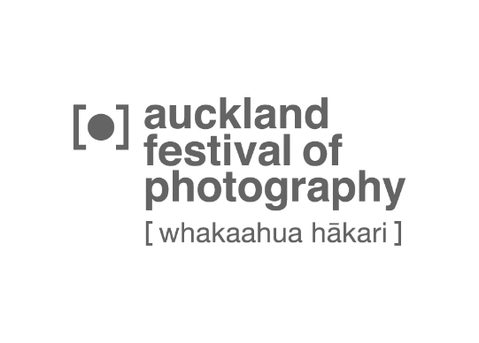 Media release, April 2021 1/1

2021 Auckland Festival of Photography (3-20 June)

Isolation and participation are elements underpinning 2021's Auckland Festival of Photography, at 50 regional venues/locations, including Auckland’s waterfront during June.

AFP's isolation theme explores Covid-19's impact on NZ and international communities and how we look to photographers to navigate the difficult questions that isolation, and emerging from it, can present.

"As naturally social animals, humans living in a state of isolation suggests an abnormal circumstance or tragedy. A space of aloneness can suddenly be filled with the difficult questions in life too profound to confront in company, a space in which creativity can flourish. This is perhaps why we reserve a certain mythical and mystical belief in the isolated artist. We believe they have confronted the questions."
- AFP 2021 programme

Momentum for the Award winning festival is building, with online public competitions in April, May and June, and a 5th annual award for exhibiting photographers.

Cash prizes of $1200 are offered in the Alex Mao Youth Award (entries close April 30) and $1500 the UNESCO Music Photography Award (May 1-24), with Fujifilm X series camera prizes for 1st, 2nd, 3rd & People’s Choice winners of AFP's annual Auckland Photo Day on June 12. AFP exhibiting artists and photographers can enter the Late Harvest Award (April 16 to May 27), with two cash prizes of $1500 and $750 on offer from winesearcher.com.

Highlights of 2021’s festival include Core, Satellite and tertiary exhibitions, Digital Screen projections and the Talking Culture weekend series featuring many leading exhibitors.

Full programe details photographyfestival.org

Media liaison:
Victor van Wetering, media liaison, AFP victorvw@xtra.co.nz 09 849 6565
Julia Durkin, Auckland Festival of Photography, (09) 307 7055, 0274 735 443

