Media release, June 2016 1/4

Image stacked with memories wins
2016 Nikon Auckland Photo Day

The winners of 2016’s Nikon Auckland Photo Day have been decided:

First prize: Sylvie Whinray for Pop's Desk
Second prize: Maria Hyun for Early Morning on the Waitemata Golf Course
Third prize: Rafael Ben-Ari’s Washing Day
Moving image winner: Angela Asuncion’s The Last Night

The judges sifted through more than 1000 entries for this year’s 24-hour day in the life of Auckland competition, held on Saturday 11 June. The entries add to a unique archive of more than 12,000 images taken of Auckland since the competition began in 2004. This year’s competition – which included a new, moving image category for the best short film, video, time-lapse or multimedia entry – was judged by photographer James K Lowe; Greg Olesen, for Nikon NZ; and photographer Mareea Vegas – who won Nikon Auckland Photo Day 2011.

Pop’s Desk by photographer Sylvie Whinray, Swanson - First prize, a Nikon D5500, a DX-format camera packed into a compact and lightweight frame, paired with a versatile Nikkor 18-55mm lens.
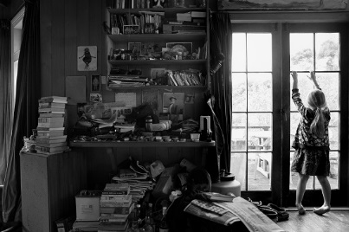

Judges’ comment: “The black and white ‘home’ image shows the complex nature of childhood, and opens the discussion of the value of the grandfather’s memories, which is shown by the child’s attention being away from the desk and on the light of the day beckoning through the window on a rainy winter’s day.”
Sylvie is a freelance photographer and mother of two children. “This picture is about my father, the passing of time and the generations of our family. All those items on my father’s desk mean something to him, or served a practical use, and have been accumulating for about 30 years. It looks like clutter but he knows where everything is. That’s where he puts his special things. He’s a pretty interesting person. This is a visual picture of his life and his interests. For example, the photo of the man in the hat is my great, great grandfather in 1906. It was a picture of him when he won a prize for making furniture. All the little black and white photos are of my siblings and me. There’s bits of history and politics, newspaper clippings, writings and notes. It’s a multigenerational portrait of our family.”
Media release, June 2016 2/4

The announcement of Nikon Auckland Photo Day winners marks the close of 2016’s festival, which featured more than 100 exhibitions and events, including a display of shortlisted entries from 11 years of competitions in The Cloud this month.

This year’s winners will be presented their prizes at The Cloud this week [11.30 a.m., Saturday 25 June], with the ‘people’s choice’ winner decided by online voting at http://www.photographyfestival.org.nz/photo-day/peoples-choice/index.cfm

“Nikon are very proud to be a key sponsor of such a great Festival that celebrates community and photography and high calibre of work from Aucklanders,” says Andrew Graham, Nikon NZ Product Manager, Lacklands. “Nikon are very pleased that, once again, Aucklanders have embraced the opportunity to create new images of the scenes, people and places that reflect their region.”

Early Morning at the Waitemata Golf Course by photographer Maria Hyun, Takapuna - Second prize,
a Nikon D3300 a sharp shooting compact DX-format DSLR, paired with a Nikkor 18-55mm lens.
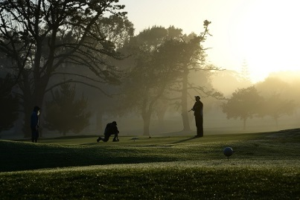

Judges’ comment: “Multiple layers to this image, depth, shadowing, and nicely silhouetted, classic Saturday early morning captured with lighting in the foreground of the golfers on the green”
Maria has been a Waitemata Golf Club member for ten years and took her winning image early on the morning of June 11.

For more information and interview opportunities, please contact:
Victor van Wetering, media manager, Auckland Festival of Photography, (09) 849 6565.

Media release, June 2016 3/4

“We are delighted with the response to this year’s competition, and very pleased with Nikon’s support of this event,” says AFP public participation director Julia Durkin.

“This is the region’s longest running photography competition. Like AFP’s fringe programme, Nikon Auckland Photo Day demonstrates a commitment to photography as something everyone can relate to and take part in, as a creative and personal means of expression.”

Washing Day by freelance photojournalist and travel photographer Rafael Ben-Ari - Third prize,
a Nikon 1 J5, with extreme portability, style and imaging power, with a compact 1 Nikkor 10-33mm lens.
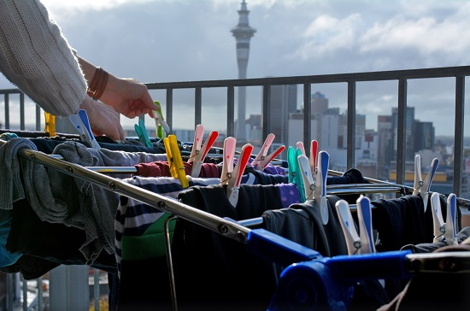

Judges’ comment: “The 3rd prize-winning image shows the juxtaposition of the ‘happy pegs’ against the grey of the Sky Tower and sky, a narrative about apartment living by new city dwellers who are trying to get washing dry in changing weather conditions on the day”.
Rafael was a war photographer in Israel before settling in New Zealand, moving to live in central Auckland 10 months ago.

For more information and interview opportunities, please contact:
Victor van Wetering, media manager, Auckland Festival of Photography, (09) 849 6565.

Media release, June 2016 4/4

The Last Night by Angela Rose Asuncion, moving Image prize,
a Nikon Coolpix AW130, waterproof, shockproof, dust and cold resistant, built in WiFi

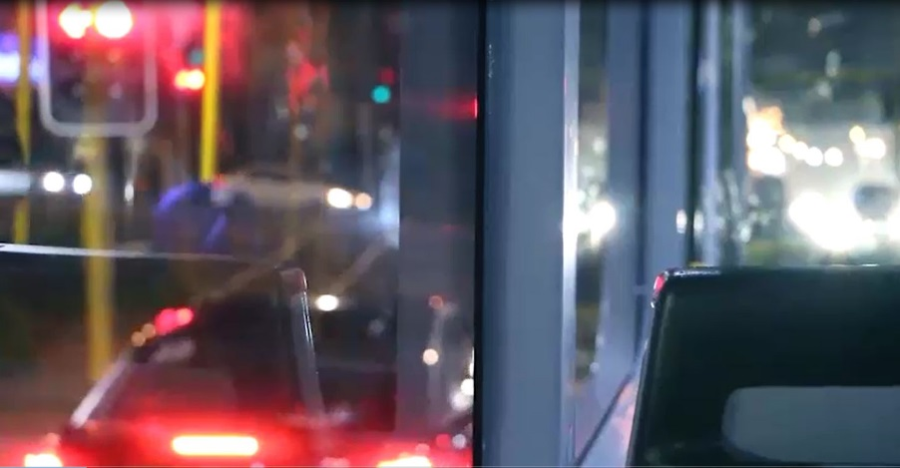

Judges’ comment: “The stand out entry, using poetry and moving image to tell a tale of young love on the late night bus ride home on the 267 service after breaking up after a brief romance.”
Angela is studying communication studies at Auckland University of Technology, majoring in digital media studies and film.

“This piece is inspired by feelings of nostalgia and missing someone before they are even gone,” Angela writes. “It’s a personal piece and the spoken word poem, as narrative voiceover, are the thoughts and emotions I felt at the time of the bus ride. Often when I take the bus home after the sun has set, I am completely enthralled by what the lights and streetlights create. I think it’s the hour, or maybe everything is just more magical in the night time where shadows and silhouettes create mysteries and the light dances playfully around us capturing our eyes. This night time bus ride was more mysterious and sombre than the usual. The night before was the last time I took - or rather will take - with the man I care for, the man I was falling for, the man I could’ve loved. I just hope we take the bus again together.”

For more information and interview opportunities, please contact:
Victor van Wetering, media manager, Auckland Festival of Photography, (09) 849 6565.

